Keyboard
Read in the keyboard
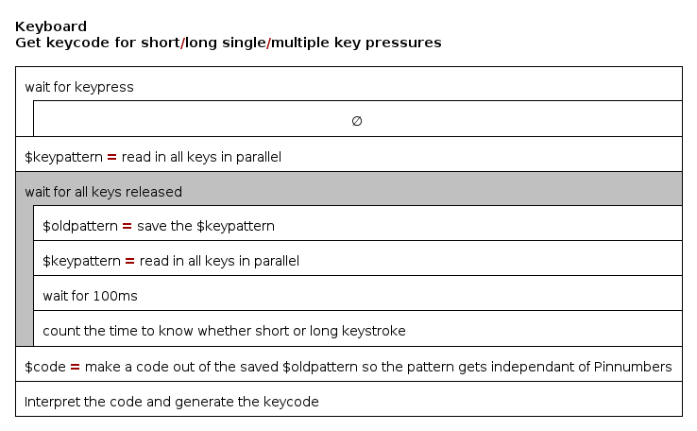
== main.cpp ==
#include <Arduino.h>
#include "keyboard.h"
#undef DEBUG

keycodes_t key1 = keycode_invalide;

void setup()
{
activatePullups();
Serial.begin(9600);
}

void loop()
{
key1 = readKeys(); //blockiert!
uint8_t x=(int)key1;
Serial.print(x,HEX);

}

== keyboard.h ==
#ifndef KEYBOARD_H_
#define KEYBOARD_H_

//Keys on PORTX/PINX
#define PINX PIND
#define PORTX PORTD
#define VOL_DN 0
#define VOL_UP 1
#define CH_DN 4
#define CH_UP 7

#ifdef DEBUG
#define DEBOUNCETIME 2
#define LONGKEYPRESSURE_MINIMALTIME 5
#else
#define DEBOUNCETIME 25
#define LONGKEYPRESSURE_MINIMALTIME 15
#endif

enum keycodes_t{
keycode_invalide,
keycode_vol_up,keycode_vol_dn,
keycode_ch_up, keycode_ch_dn,
keycode_vol_up_long,keycode_vol_dn_long,
keycode_ch_up_long, keycode_ch_dn_long, keycode_mute,
keycode_ch_search, keycode_ch_save, keycode_eeprom_clear, keycode_testmode
};

keycodes_t readKeys();
void activatePullups();

#endif /* KEYBOARD_H_ */
== keyboard.cpp ==
#include <Arduino.h>
#include "keyboard.h"

void activatePullups(){
PORTX |= (1<<VOL_UP|1<<VOL_DN|1<<CH_UP|1<<CH_DN);
}

enum keycodes_t readKeys(){

uint8_t mask = 1<<VOL_UP|1<<VOL_DN|1<<CH_UP|1<<CH_DN;
while ((PINX & mask) == mask){} //wait for key pressure
delay(DEBOUNCETIME); //debounce time
…

Analog Keyboard
Jede Taste erzeugt an einem Spannungsteiler eine eigene Spannung. Über einen Analogeingang werden die Spannungen ausgewertet. Mehrfachtastendrücke möglich (aber nicht getestet)

//short Keystrokes = Keycode 1,2,3
//long Keystrokes = 11, 12, 13
//very long Keystrokes = 101, 102, 103

uint8_t waitForKey() {
int keyTime = 0;
TRACE ("waitForKey")
int newSensorValue = 0;
DELAY (20); //let the adc recreate

while (sensorValue == 0) {
sensorValue = analogRead (analogInPin);
DELAY (50) //debounce
}

//delay(50); //let the adc settle
sensorValue = analogRead (analogInPin);
DELAY (300);
newSensorValue = analogRead (analogInPin);

while ( (newSensorValue / 100 == sensorValue / 100) && (sensorValue != 0) ) { // div by 100 to reduce sensibility
DELAY (300)
keyTime++;
newSensorValue = analogRead (analogInPin);
if (keyTime >= 2){
Radio.mute(); //feedback to user for long key pressure
delay(50);
Radio.unMute();
}
if (keyTime > 6){
Radio.mute(); //feedback to user for very long key pressure
delay(500);
Radio.unMute();
}
}

int keyValue = map (sensorValue, 0, 1023, 0, 5);

if (keyTime >= 2 && keyTime <= 6)
{ keyValue += 10;

}
else if (keyTime > 6)
{ keyValue += 100;

}

sensorValue = 0;

return keyValue;
}

