Development Boards ESP32

Wroom ESP32
Inhaltsverzeichnis
Wroom ESP32 1
DEVKIT-C1 1
VisualCode Plugin für DEVKIT-C1 1
Programmierung 1
D1 ESP32-S3 WiFi+Bluetooth-compatible Flash D1 R3 Board Module CH340 N16R8 For UNO ESP-32 Development Board Wireless Module 2
ESP32-S3-DevKitC-1 Board, APKLVSR WROOM-1-N16R8 8
APKLVSR ESP32-S3-DevKitC-1 Board mit WiFi, Bluetooth 5.0 kompatibel mit Arduino 8
Wie man den ESP32-53 herunterlädt: 10
Features 11

DEVKIT-C1

VisualCode Plugin für DEVKIT-C1
https://github.com/espressif/vscode-esp-idf-extension/blob/master/docs/tutorial/install.md
https://marketplace.visualstudio.com/items?itemName=espressif.esp-idf-extension

Programmierung
: IO0 muss auf GND, dann RESET und Programmierung über Serial Port
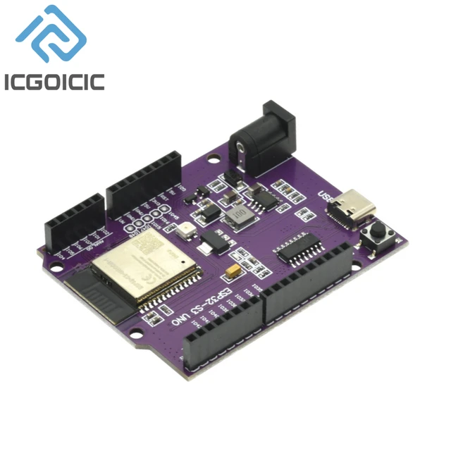


D1 ESP32-S3 WiFi+Bluetooth-compatible Flash D1 R3 Board Module CH340 N16R8 For UNO ESP-32 Development Board Wireless Module

Description
Report Item

- CPU: Xtensa® 32-bit LX7 dual-core processor, up to 240 MHz
- RAM:512 KB
- ROM:384 KB
- Flash:8 MB or 16 MB
- Wi-Fi:IEEE 802.11b/g/n/ax, 2.4 GHz, up to 1.5 Gbps
- Bluetooth:Bluetooth® 5.0, BLE
- Interfaces:UART, SPI, I2C, SDIO, USB, GPIO
- Power:3.3 V
- Dimensions:20 mm x 20 mm
Here are some additional details about the ESP32-S3 module's parameters:
- CPU:The ESP32-S3 uses a Xtensa® 32-bit LX7 dual-core processor with a maximum clock speed of 240 MHz. This provides the module with excellent performance for a variety of applications.
- RAM:The ESP32-S3 has 512 KB of RAM, which is sufficient for most applications.
- ROM:The ESP32-S3 has 384 KB of ROM, which is enough for storing firmware and other data.
- Flash:The ESP32-S3 is available with 8 MB or 16 MB of flash memory. This allows you to store large amounts of data, such as images, audio, or video.
- Wi-Fi:The ESP32-S3 supports IEEE 802.11b/g/n/ax Wi-Fi with a maximum speed of 1.5 Gbps. This makes it ideal for applications that require high-speed wireless connectivity.
- Bluetooth:The ESP32-S3 supports Bluetooth® 5.0, which provides a wide range of features and capabilities.
- Interfaces:The ESP32-S3 has a variety of interfaces, including UART, SPI, I2C, SDIO, USB, and GPIO. This makes it easy to connect the module to other devices and systems.
- Power: The ESP32-S3 operates at 3.3 V.
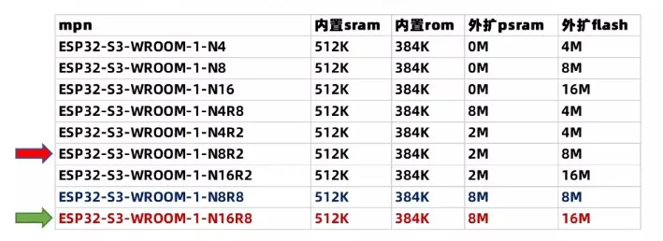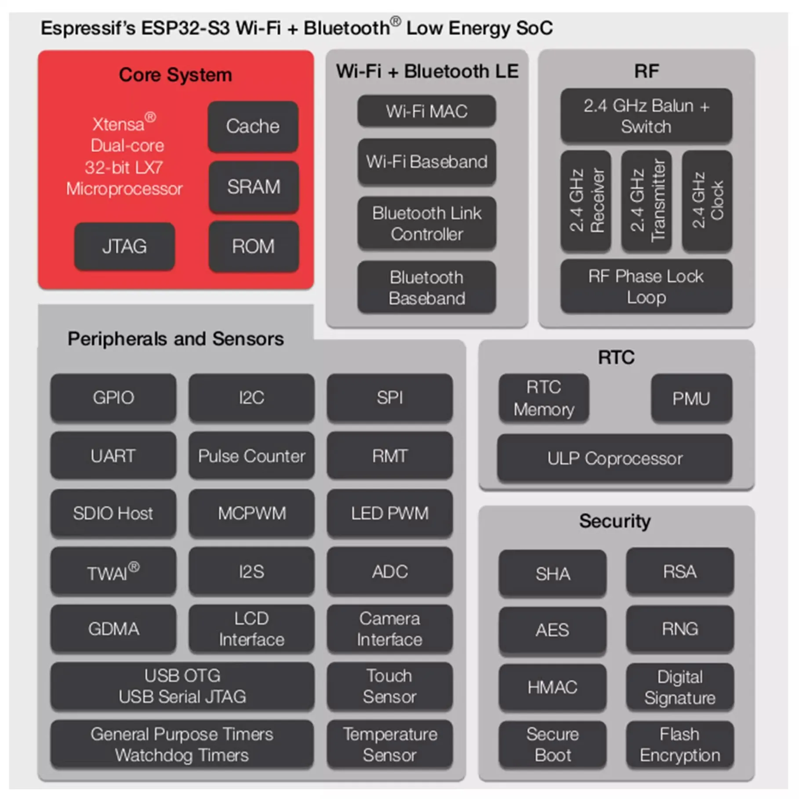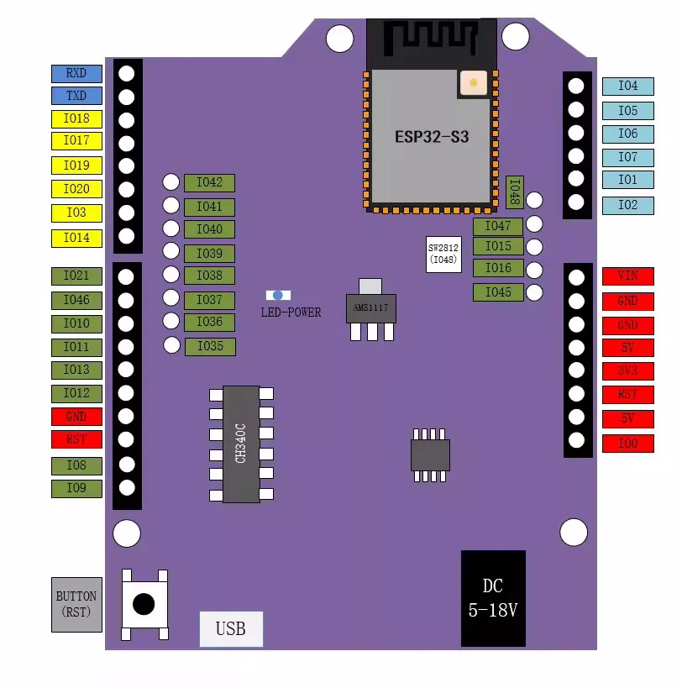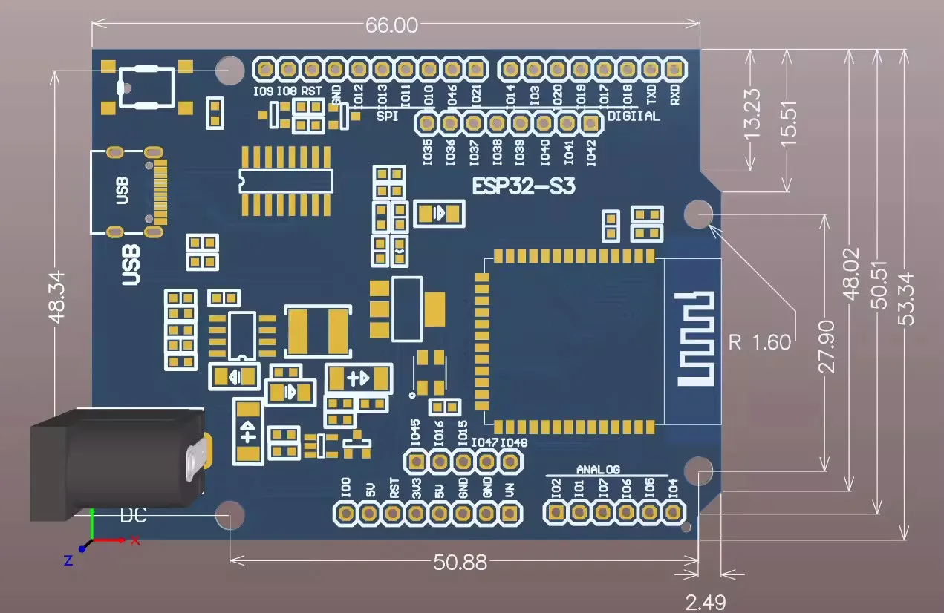

ESP32-S3-DevKitC-1 Board, APKLVSR WROOM-1-N16R8

https://www.amazon.de/dp/B0CQNB74R9/ref=pe_27091401_487024491_TE_item

APKLVSR ESP32-S3-DevKitC-1 Board mit WiFi, Bluetooth 5.0 kompatibel mit Arduino
- https://mischianti.org/vcc-gnd-studio-yd-esp32-s3-devkitc-1-clone-high-resolution-pinout-and-specs/
- Schematic
https://mischianti.org/wp-content/uploads/2023/08/YD-ESP32-S3-SCH-V1.4.pdf
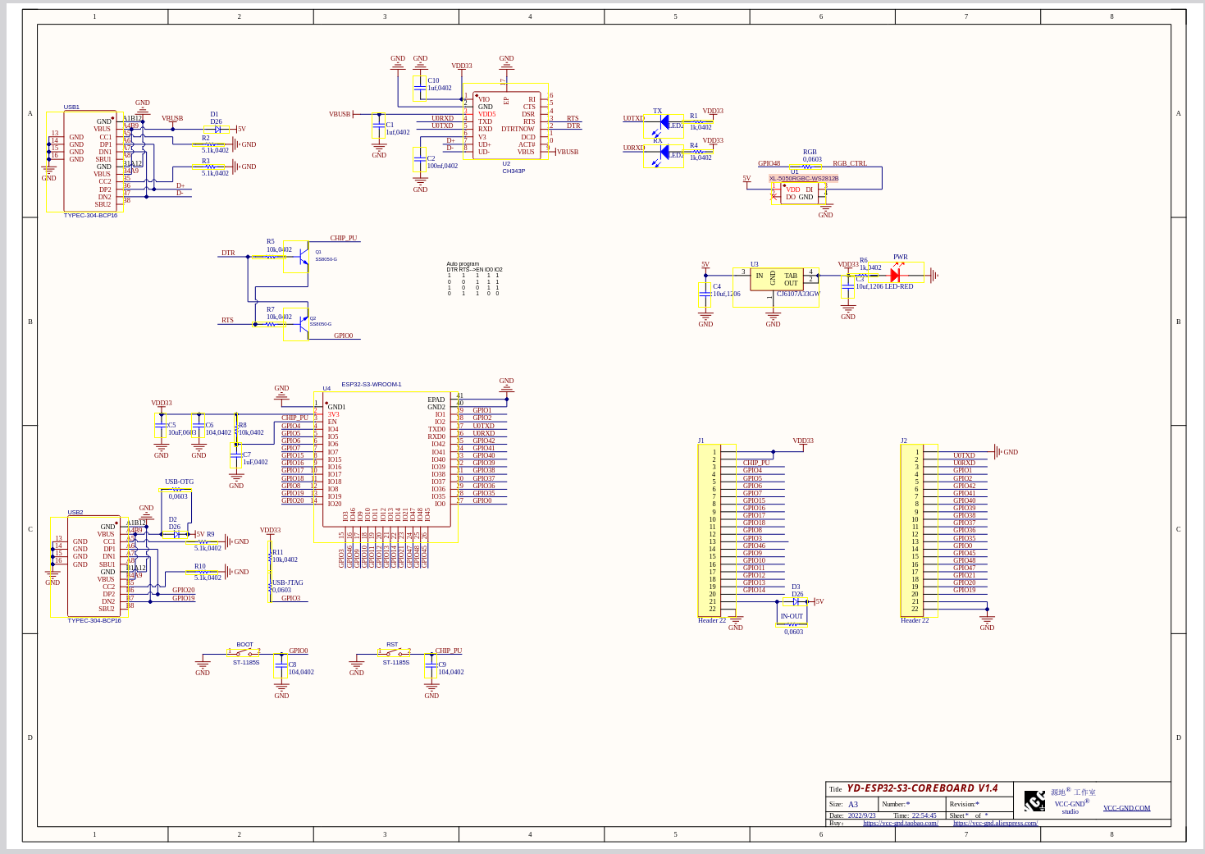
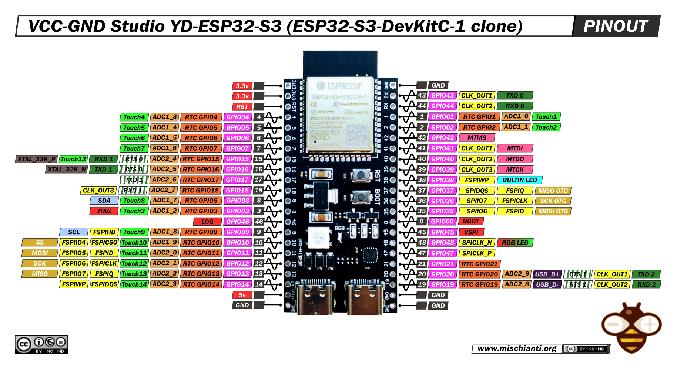
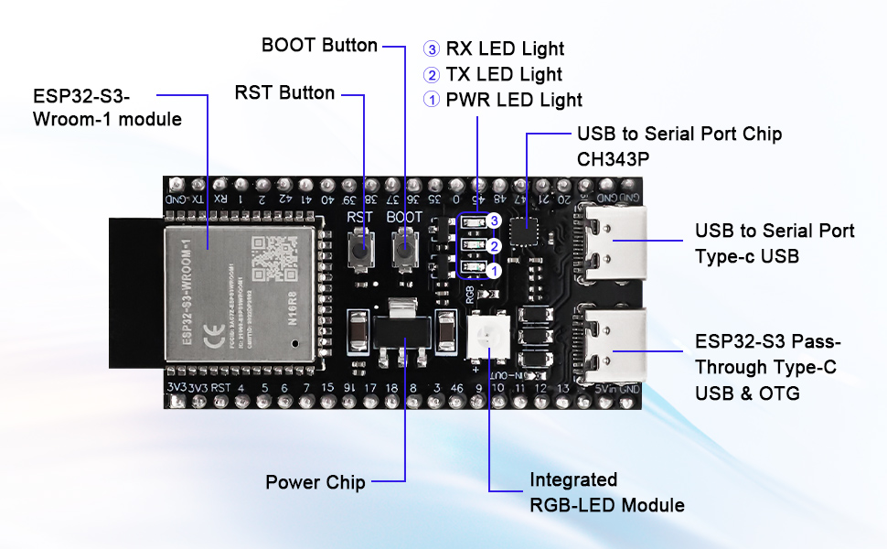

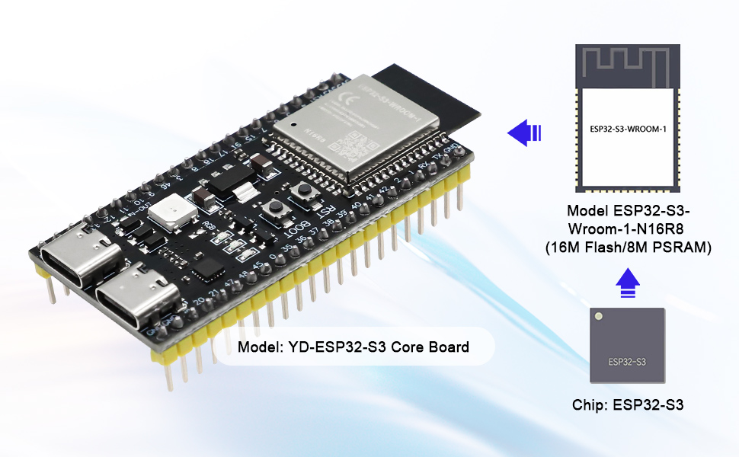

Features

Verschlüsselungs-Hardware-Beschleuniger:
- AES- 128/256 (FIPS PUB 197)
- Hash (FIPS PUB 180-4)
- Zufallszahlengenerator (RNG)
- RSA
- HMAC
- Digitale Unterschrift

Niedrige Energieverwaltung:
Power Management Einheit, fünf Stromverbrauchsmodi
Ultra-Low-Power-Prozessor (ULP):
ULP-RISC-V Koprozessor
ULP-FSM-Koprozessor

Sicherheitsmechanismus：
Sicherer Start
Flash-Verschlüsselung
4096 Bit OTP, Benutzer können bis zu 1652 Bit verwenden
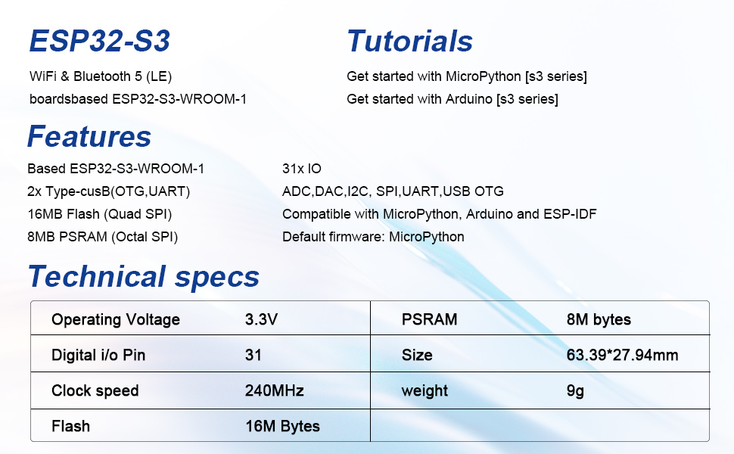

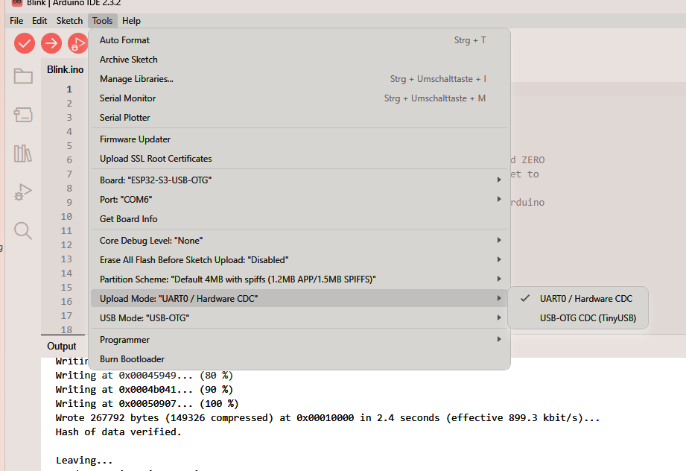
Einstellungen für Arduino IDE

